Project Description:
Project description template Movie Database Management System
Brief project and dataset description (1-2 paragraphs): The Movie Database Management System is designed to manage information about various movies. The dataset is stored in a text file (movies_v2.txt), and the system provides functionalities such as adding a new movie, finding a movie by name, showing movies based on specified criteria, sorting movies, generating random arrays, and performing time complexity analysis on sorting algorithms.
Project functionalities:
- Option 1: Add movie - Calls the function add_movie(movies_dict: dict, name: str, rating: float, duration: int, year: int, genre: str, gross_income: int) to add a new movie to the database.
- Option 2: Find movie by name - Calls the function find_movie_by_name(movies_dict: dict, name: str) to find and display information about a movie by its name.
- Option 3: Show movies of year and rating - Displays movies based on specified rating and year range using the function find_movies_by_rating_and_year(movies_dict: dict, min_rating: float, max_rating: float, start_year: int, end_year: int).
- Option 4: Sort by genre - Sorts movies by a specified genre using the function find_movies_by_genre(movies_dict: dict, user_genre: str).
- Option 5: Sort from old to new films - Calls the function get_sorted_years_and_movies(movies_dict: dict) to get sorted years and associated movies.
- Option 6: Random array (rating) - Calls sample_array(arr: np.ndarray, n: int) to generate a random array of movie ratings.
- Option 7: Array with rating sorted from min to max - Calls sort_array(arr: np.ndarray) to display an unsorted and sorted array of movie ratings.
- Option 8: Graph with sorted and unsorted ratings - Calls plot_sorting(arr: np.ndarray) to plot and display the sorted and unsorted movie ratings.
- Option 9: - time_sorting - Calls time_sorting(sizes: np.ndarray, data: np.ndarray) to perform time complexity analysis on sorting algorithms.
- Option 10: Exit - Exits the application.
Discussion: I discuss the runtime analysis, comparing expected results based on Big-O analysis with the actual findings. Images of the plots are included.
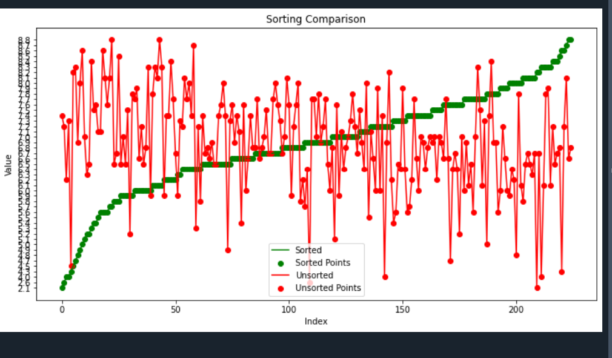
Figure 18. Option 8: Graph with sorted and unsorted ratings - Calls plot_sorting(arr: np.ndarray) to plot and display the sorted and unsorted movie ratings.
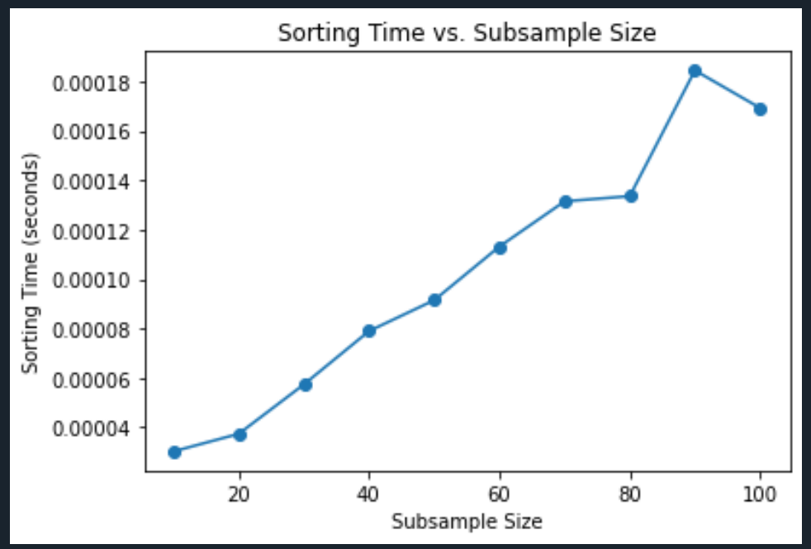
Figure 29. Option 9: - time_sorting - Calls time_sorting(sizes: np.ndarray, data: np.ndarray) to perform time complexity analysis on sorting algorithms.
Authorship declaration: I certify that this assignment represents my own work. I have not used any unauthorized or unacknowledged assistance or sources in completing it. This includes free or commercial systems or services offered on the internet or text-generating systems embedded in software. I have given credit for the help received in conceptualizing my project. My work adheres to the university and course code of conduct.

Datasets:

Movie Dataset
- Features: name, rating, duration, year, genre, gross_income.
- 696 entries with 6 features.
- Movie Dataset
- The first dataset was provide is an adventure movie dataset. A link to the full dataset can be found here. We have cleaned and filtered the dataset. In the provided dataset, the entries are movies and the features are the following :
- • name - Name of the Movie
- • rating - Rating of the Movie
- • duration - Duration of the Movie
- • year - Year of movie release
- • genre - Genre of the Movie
- • gross_income - Gross Income of the Movie
- There are 696 entries and 6 features.

I certify that this assignment represents my own work. I have not used any unauthorized or
unacknowledged assistance or sources in completing it including free or commercial systems
or services offered on the internet or text generating systems embedded into software. I have
given credit for the help I had conceptualizing my project. My work respects the university and
course code of conduct.

